

**Western Australian Certificate of Education**

**ATAR course examination, 2018**

**Question/Answer Booklet**

12 PHYSICS

Name

**Test 1 – Projectile Motion**

|  |  |  |  |  |  |  |  |  |  |  |
| --- | --- | --- | --- | --- | --- | --- | --- | --- | --- | --- |
| Student Number: In figures |  |  |  |  |  |  |  |  |  |  |

**Mark: $\frac{}{\text{56}}$**  In words

#### Time allowed for this paper

Reading time before commencing work: five minutes

Working time for paper: sixty minutes

**Materials required/recommended for this paper**

To be provided by the supervisor

This Question/Answer Booklet

Formulae and Data Booklet

***To be provided by the candidate***

Standard items: pens, (blue/black preferred), pencils (including coloured), sharpener, correction fluid/tape, eraser, ruler, highlighters

Special items: non-programmable calculators satisfying the conditions set by the School Curriculum and Standards Authority for this course

**Important note to candidates**

No other items may be taken into the examination room. It is your responsibility to ensure that you do not have any unauthorised notes or other items of a non-personal nature in the examination room. If you have any unauthorised material with you, hand it to the supervisor before reading any further.

**Structure of this paper**

|  |  |  |  |  |  |
| --- | --- | --- | --- | --- | --- |
| Section | Number of questions available | Number of questions to be answered | Suggested working time  (minutes) | Marks available | Percentage of exam |
| Section One:  Short Answers | - | - | - | - | - |
| Section Two:  Problem-solving | 7 | 7 | 60 | 56 | 100 |
| Section Three:  Comprehension | - | - | - | - | - |
|  |  |  |  | **Total** | 100 |

**Instructions to candidates**

1. The rules for the conduct of examinations at Holy Cross College are detailed in the College Examination Policy*.* Sitting this examination implies that you agree to abide by these rules.

2. Write your answers in this Question/Answer Booklet.

3. Working or reasoning should be clearly shown when calculating or estimating answers.

4. You must be careful to confine your responses to the specific questions asked and to follow any instructions that are specific to a particular question.

5. Spare pages are included at the end of this booklet. They can be used for planning your

responses and/or as additional space if required to continue an answer.

• Planning: If you use the spare pages for planning, indicate this clearly at the top of the page.

• Continuing an answer: If you need to use the space to continue an answer, indicate in the original answer space where the answer is continued, i.e. give the page number. Fill in the number of the question(is) that you are continuing to answer at the top of the page.

6. Answers to questions involving calculations should be ***evaluated and given in decimal***

***form*.** It is suggested that you quote all answers to ***three significant figures***, with the

exception of questions for which estimates are required. Despite an incorrect final result, credit may be obtained for method and working, providing these are ***clearly and legibly set out***.

7. Questions containing the instruction "estimate" may give insufficient numerical data for their solution. Students should provide appropriate figures to enable an approximate solution to be obtained. Give final answers to a maximum of two significant figures and include appropriate units where applicable.

8. Note that when an answer is a vector quantity, it must be given with magnitude and direction.

9. In all calculations, units must be consistent throughout your working.

1. A cart that is rolling at constant velocity fires a ball straight up. Ignoring air resistance, when the ball comes back down, will it land in front of the launching tube, behind the launching tube, or directly in the tube? Explain. (3 marks)

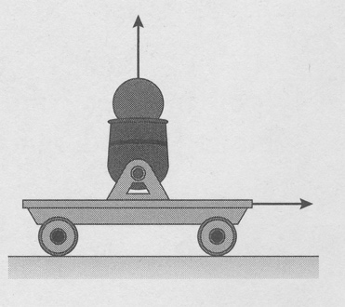

2. A golfer is teeing off on a 170.0 m long par-3 hole. The ball leaves with a velocity of

40.0 ms–1 at 50.0o to the horizontal. Assuming that she hits the ball on a direct path to the hole and that the hole is level with the tee. Ignoring air resistance, how far from the hole will the ball land? (5 marks)

3. Consider the hammer (the ball on the end of the chain) shown in the diagram below.

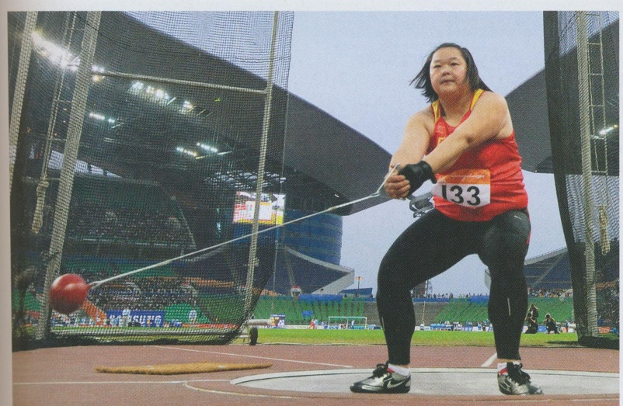

Assuming that the hammer is released from a position just above the ground, as shown, at a speed of 98.0 kmh–1. What is the maximum distance the hammer can travel? Ignore air resistance and the effect of the chain. (5 marks)

4. A fielder throws a baseball with a horizontal component of velocity of 25.0 ms–1. It takes

3.00 s to come back to its original height. Ignoring air resistance, calculate:

(a) its horizontal range. (1 mark)

(b) its initial vertical component of velocity. (2 marks)

(c) its initial angle of projection. (3 marks)

5. The figure shows a skier that skis down a quarter-circle ramp, then off a cliff. Ignore air resistance in this question.

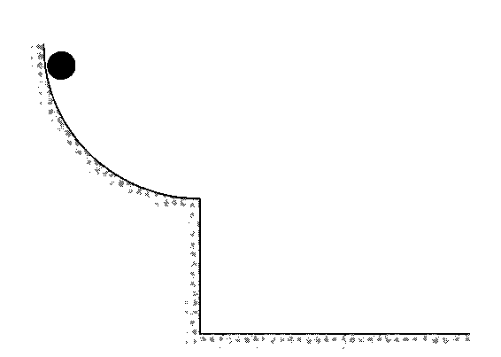

(a) Sketch the skier's trajectory from the instant she is released until she hits the ground.

(2 marks)

(b) The skier leaves the end of a ramp with a horizontal velocity of 25.0 ms–1 and lands 70.0 m from the base of the ramp. How high is the end of the ramp from the ground?

(3 marks)

(c) Determine the skier’s velocity 2.00 s after leaving the end of the ramp. (6 marks)

6. An astronaut stands on the edge of an asteroid crater and uses a launcher to project an object with a velocity of 5.00 ms–1 at an angle of 65.0° above horizontal. The floor of the crater is 100.0 m below the astronaut. The object travels a horizontal distance of 55.3 m before hitting the floor of the crater. There is no atmosphere on the asteroid.

(a) Determine the acceleration of gravity on the asteroid. (6 marks)

(b) How high above the crater floor did the object rise? (3 marks)

7. Paul kicks a ball from point P to point R. At the same instant, Quinn starts from point Q and runs forward, to catch the ball at point R. The horizontal distance between P and Q when Paul kicks the ball is 15.0 m. The initial vertical velocity (uv) of the ball is 12.0 ms–1 and its horizontal velocity (uh) is 10.0 m s–1. Ignore air resistance throughout this question.

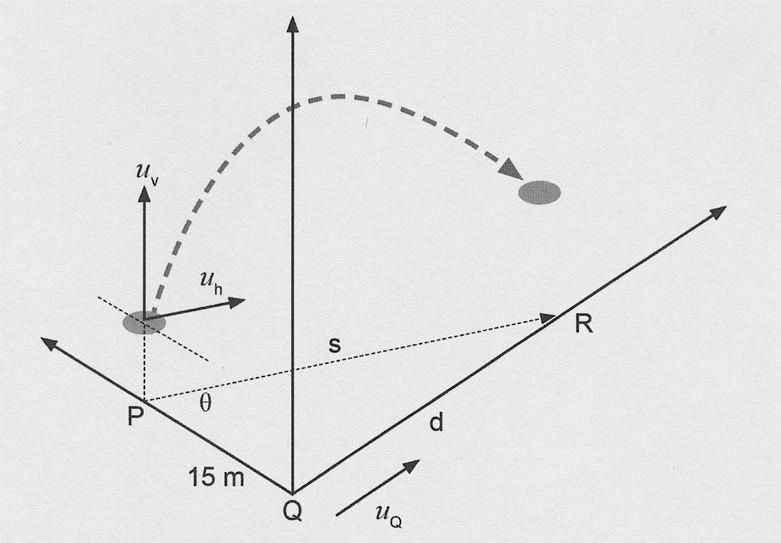

(a) Calculate the initial velocity of the ball. (3 marks)

(b) Paul kicks the ball 1.00 m above the ground. Quinn jumps and catches the ball when it is 3.00 m above the ground at point R.

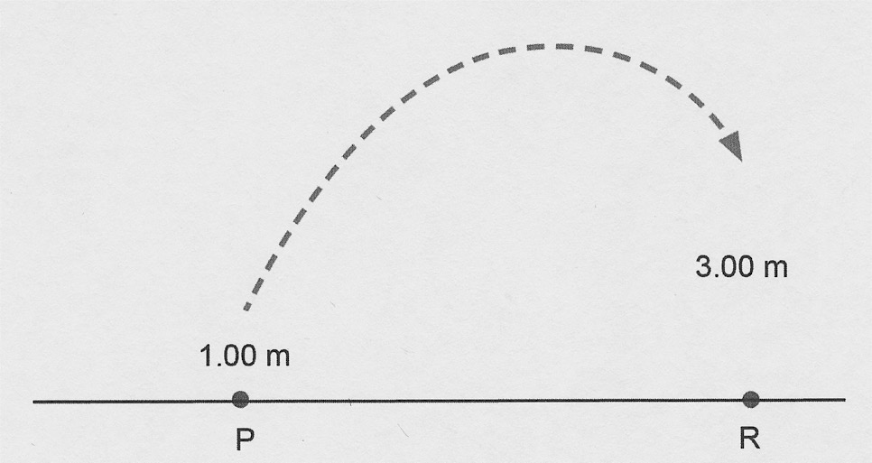

(b) (i) Show by calculation that the total time taken by the ball in the air to get from 1.00 m above the ground to 3.00 m above the ground could be either about 0.2 s or about 2.3 s. (4 marks)

(ii) Which of the two ***calculated*** time values in part (b) (i) is more appropriate for the ball to travel to Quinn? State a reason why. (2 marks)

(c) Determine the horizontal distance (*s*) the ball will cover before Quinn catches it at

point R. (2 marks)

(d) Determine the average speed at which Quinn would need to travel from point Q to be able to catch the ball at point R. (3 marks)

(e) If the ball were to be ***kicked from the ground***, determine the ground angle (θ), as shown on the diagram below, at which Paul needs to kick the ball so that the ball has the same velocity at position P as originally stated. (4 marks)



1.00 m

*θ*